

PROPOSAL DOCUMENT

Vulnerability Assessment &
Penetration Testing (VAPT) Report

Ambledown Financial Services

05th June 2025
© Sautech (Pty) Ltd. http://www.sautech.net

TABLE OF CONTENTS

1 Executive summary 3
2 scope of testing 3
3 Methodologies used 3
3.1 Nmap / Zenmap 3
3.2 Tenable Nessus 3
3.3 Greenbone Enterprise 4
Stay One Step Ahead of Attackers 4
3.4 OWASP 5
3.5 Brute Force 5
Applications used in Brute Force Include: 5
4 SCOPE OF SERVERS 6
4.1 Ambledown Domain Controller – 192.168.0.22 6
4.2 Ambledown Firewall Internal – 192.168.0.1 (GREENBONE) 6
4.3 Ambledown HO Firewall – 41.169.103.84 6
4.4 Ambledown Live Server – 102.67.139.234 10
4.5 Ambledown UAT Server – 154.0.171.224 12
5 NETWORK CONFIGURATION AND SECURITY pOLICIES 17
5.1 Internal Network Scan 17
5.2 Ambledown User List 17
5.3 Password Policies 19
5.4 Domain Policies 20
5.5 Domain Admin Users 20
5.6 System Information 21
5.7 Server Windows Updates 21
5.8 Server OS 22
5.9 FortiGate Firewall 22
5.10 Firewall Information 22
5.11 Wireless Network 23
6 Reporting Conclusion 24
7 Auditors 25

Executive summary
The objective of this assessment was to identify security vulnerabilities, business logic flaws, and missing best security practices. The tests were conducted from the perspective of an attacker or malicious user, without causing any disruption to the functionality or performance of the application or network. Additionally, a comprehensive scan of the infrastructure was performed to simulate a real-world attack scenario, such as an internal network breach or exposure on a shared public subnet.
The assessment, including scans and testing, was carried out over seven (7) business days to ensure a thorough and methodical audit. These scans also examined unidentified connectivity options, such as packet SYN requests.

The overall results will be published below.
Recommendations are offered and mentioned throughout this document.

scope of testing

Security assessments include testing for security loopholes in the scope defined below. Apart from the following, no other information was provided. Nothing was assumed at the start of the security assessment. The following scope of servers were covered under the security audit:

- Ambledown Domain Controller – 192.168.0.22
- Ambledown Firewall Internal – 192.168.0.1
- Ambledown HO Firewall – 41.169.103.84
- Ambledown Live Server – 102.67.139.234
- Ambledown UAT Server – 154.0.171.224

Methodologies used

Sautech performed various audit techniques that includes the following:

Nmap / Zenmap

Nmap, short for Network Mapper, is a free and open source tool used for vulnerability checking, port scanning and, of course, network mapping. Despite being created back in 1997, Nmap remains the gold standard against which all other similar tools either commercial or open source, are judged.

To deploy Nmap, users originally had to have some advanced programming skills, with the introduction of the Zenmap tool for Nmap, which adds a graphical interface that makes launching the program and analysing the returned output it generates much more accessible.

Tenable Nessus

Nessus is a remote security scanning tool, which scans a computer and raises an alert if it discovers any vulnerabilities that malicious hackers could use to gain access to any computer you have connected to a network. It does this by running over 1200 checks on a given computer, testing to see if any of these attacks could be used to break into the computer or otherwise harm it.

Greenbone Enterprise
Greenbone is the world’s most widely used vulnerability management provider.

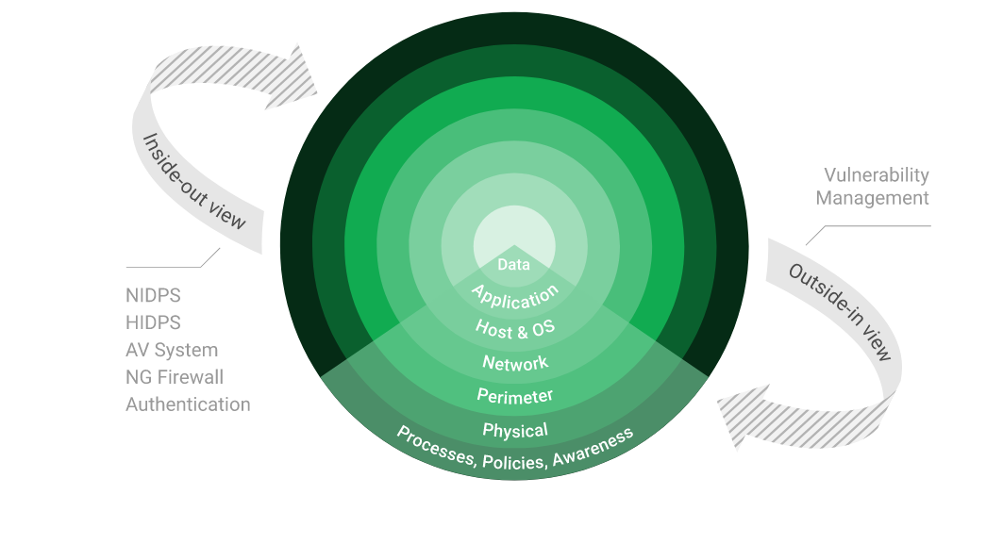

Stay One Step Ahead of Attackers
IT security is a process – Open Source vulnerability management provides the foundation. Once you know where the chinks are in your armor, you can do something about them.

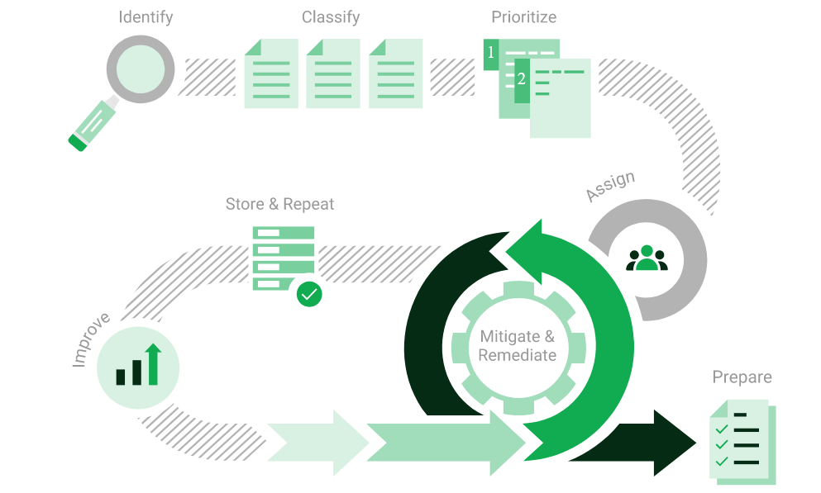

The process – from recognition to remedy and monitoring – represents a continuous cycle. You’ll always be one step ahead of attackers.

OWASP

The Open Web Application Security Project (OWASP) is an online community that produces freely-available articles, methodologies, documentation, tools, and technologies in the field of web application security. The Open Web Application Security Project (OWASP) provides free and open resources. It is led by a non-profit called The OWASP Foundation. The OWASP Top 10 - 2021 is the published result of recent research based on comprehensive data compiled from over 40 partner organizations.

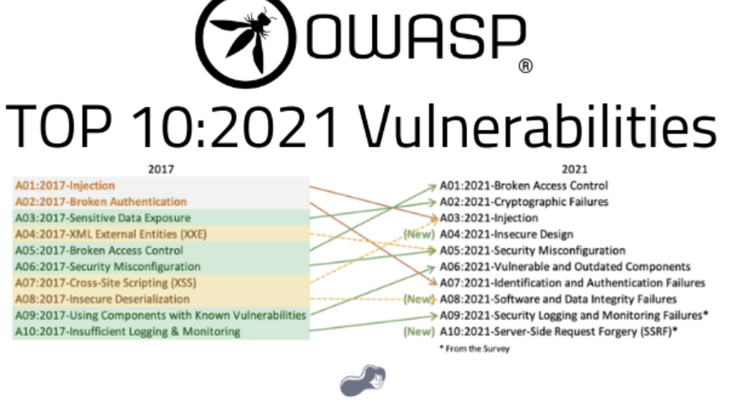

Brute Force

- A brute force attack is a hacking method that uses trial and error to crack passwords, login credentials, and encryption keys. It is a simple yet reliable tactic for gaining unauthorized access to individual accounts and organizations’ systems and networks. The hacker tries multiple usernames and passwords, often using a computer to test a wide range of combinations, until they find the correct login information.

- The name "brute force" comes from attackers using excessively forceful attempts to gain access to user accounts. Despite being an old cyberattack method, brute force attacks are tried and tested and remain a popular tactic with hackers.

Applications used in Brute Force Include:

Hydra is a parallelized network login cracker built in various operating systems like Kali Linux, Parrot and other major penetration testing environments. Hydra works by using different approaches to perform brute-force attacks in order to guess the right username and password combination. Hydra is commonly used by penetration testers together with a set of programmes like crunch,[2] cupp[3] etc, which are used to generate wordlists. Hydra is then used to test the attacks using the wordlists that these programmes created.

Over 2.5 Million + Username and password combos are used to Brute force application like RDP, SSH etc.

SCOPE OF SERVERS

Ambledown Domain Controller – 192.168.0.22

We have performed the following types of scans / attacks on the production server namely:

- Greenbone Enterprise - The Greenbone Report will be provided as a separate attachment.

Ambledown Firewall Internal – 192.168.0.1 (GREENBONE)

We have performed the following types of scans / attacks on the production server namely:

- Greenbone Enterprise - The Greenbone Report will be provided as a separate attachment.

Ambledown HO Firewall – 41.169.103.84

We have performed the following types of scans / attacks on the production server namely:

- Greenbone Enterprise - The Greenbone Report will be provided as a separate attachment.
- OWASP – The OWASP Report will be provided as a separate attachment.
- Port Mapping – Nmap / Zenmap (Open / Exposed Services) These were performed from unknown and known locations to test not just the security from the perimeter, but also include local network. Based on the port mapping open access to Public and Private, selected coordinated assessments were performed specific to the open connectivity received.
- Vulnerability Assessments – Tenable Nessus.
- Brute Force Attacks – Hydra.

Port Mapping – Nmap / Zenmap
Nmap can be used by hackers to gain access to uncontrolled ports on a system. All a hacker would need to do to successfully get into a targeted system would be to run Nmap on that system, look for vulnerabilities, and figure out how to exploit them.

The below screenshot demonstrates the open network port mapping:

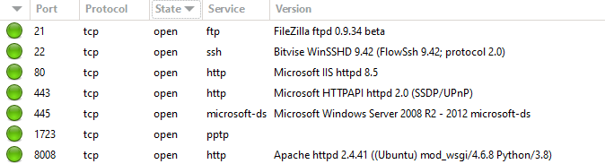

Remote Operating System Detection:

- Used Port: 21/tsp (open)
- Used Port: 22/tsp (open)
- Used Port: 80/tsp (open)

- Used Port: 443/tsp (open)
- Used Port: 445/tsp (open)
- Used Port: 1723/tsp (open)
- Used Port: 8008/tsp (open)

Vulnerability Assessment – Tenable Nessus
Multiple technologies were used to perform a vulnerability assessment, below is the summarised version of the relevant results:

We have attached the below “highlight” in a separate report so that you can click on the “Plugin” link to get the resolution.

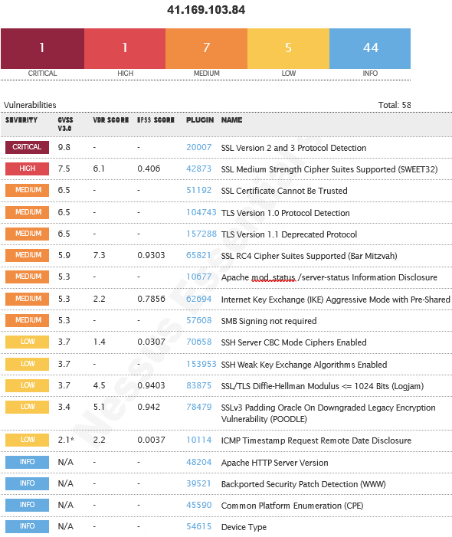
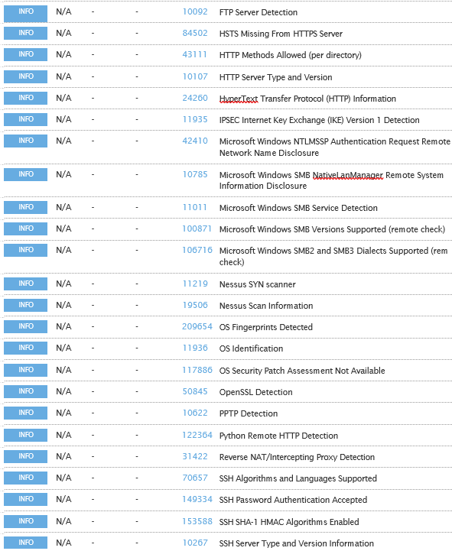
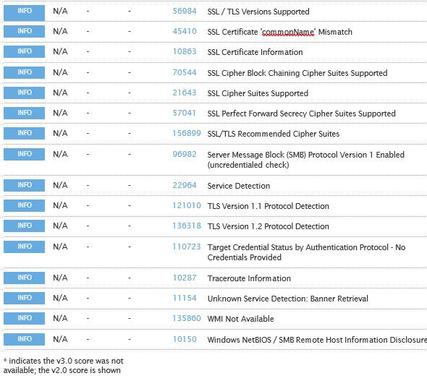

Brute Force
Randomised usernames with a word list containing more than 2.5 million words and common passwords were brute forced SSH’s onto the server using Hydra.

Hydra works by using different approaches to perform brute-force attacks in order to guess the right username and password combination. Hydra is commonly used by penetration testers together with a set of programmes like crunch, cupp etc, which are used to generate wordlists.

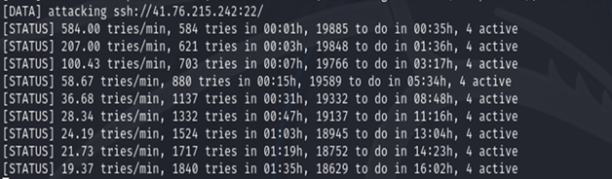
As per the HYDRA screen shot above, all know accounts have been scanned and with no passwords found. We are satisfied with the results.

Ambledown Live Server – 102.67.139.234

We have performed the following types of scans / attacks on the production server namely:

- Greenbone Enterprise - The Greenbone Report will be provided as a separate attachment.
- Port Mapping – Nmap / Zenmap (Open / Exposed Services) These were performed from unknown and known locations to test not just the security from the perimeter, but also include local network. Based on the port mapping open access to Public and Private, selected coordinated assessments were performed specific to the open connectivity received.
- Vulnerability Assessments – Tenable Nessus.

Port Mapping – Nmap / Zenmap
Nmap can be used by hackers to gain access to uncontrolled ports on a system. All a hacker would need to do to successfully get into a targeted system would be to run Nmap on that system, look for vulnerabilities, and figure out how to exploit them.

The below screenshot demonstrates the open network port mapping:

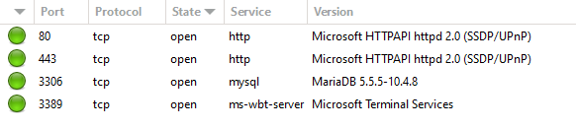

Remote Operating System Detection:

- Used Port: 80/tsp (open)
- Used Port: 443/tsp (open)
- Used Port: 3306/tsp (open)
- Used Port: 3389/tsp (open)

We Recommend closing RDP (3389) or either of the following perform RDP is accessed:

- VPN with Certificate (not username and password combination)
- Configure Local Firewall to only accept RDP connections from known source address
- Install 2FA i.e. Google Authenticator.

Vulnerability Assessment – Tenable Nessus
Multiple technologies were used to perform a vulnerability assessment, below is the summarised version of the relevant results:

We have attached the below “highlight” in a separate report so that you can click on the “Plugin” link to get the resolution.

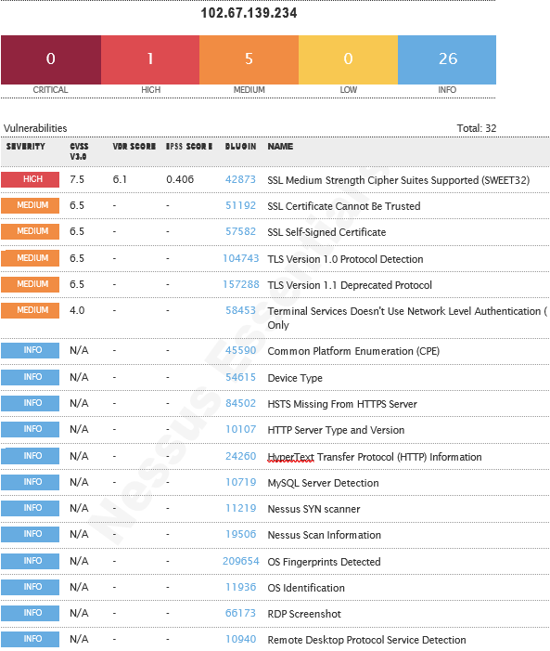

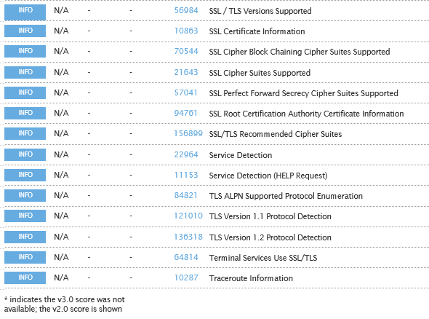

Ambledown UAT Server – 154.0.171.224

We have performed the following types of scans / attacks on the production server namely:

- Greenbone Enterprise - The Greenbone Report will be provided as a separate attachment.
- OWASP – The OWASP Report will be provided as a separate attachment.
- Port Mapping – Nmap / Zenmap (Open / Exposed Services) These were performed from unknown and known locations to test not just the security from the perimeter, but also include local network. Based on the port mapping open access to Public and Private, selected coordinated assessments were performed specific to the open connectivity received.
- Vulnerability Assessments – Tenable Nessus.
- Brute Force Attacks – Hydra.

Port Mapping – Nmap / Zenmap
Nmap can be used by hackers to gain access to uncontrolled ports on a system. All a hacker would need to do to successfully get into a targeted system would be to run Nmap on that system, look for vulnerabilities, and figure out how to exploit them.

The below screenshot demonstrates the open network port mapping:

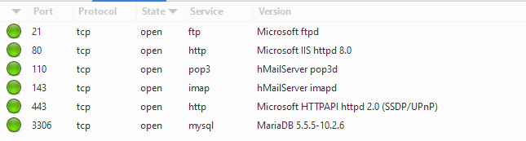

Remote Operating System Detection:

- Used Port: 21/tsp (open)
- Used Port: 80/tsp (open)
- Used Port: 110/tsp (open)
- Used Port: 143/tsp (open)
- Used Port: 443/tsp (open)
- Used Port: 3306/tsp (open)

As detected above, Windows 2012 is being used on the server. As per the Microsoft support lifecycle, there is no more support or updates available. It is critical to upgrade to a later version OS as soon as possible.

Should Port 3306 not be needed over public access, the port ought to be closed. If Port 3306 is needed over public access, we recommend it only be accessed over VPN or SSL Cert.

Vulnerability Assessment – Tenable Nessus
Multiple technologies were used to perform a vulnerability assessment, below is the summarised version of the relevant results:

We have attached the below “highlight” in a separate report so that you can click on the “Plugin” link to get the resolution.
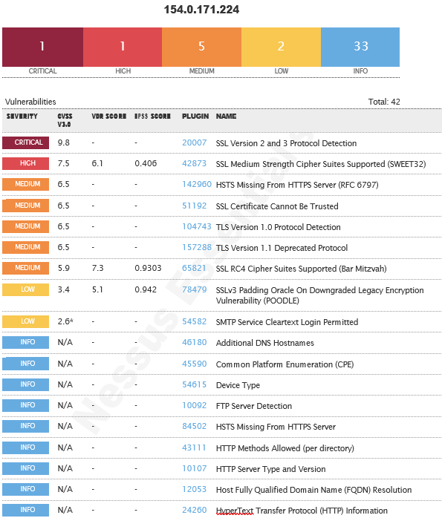

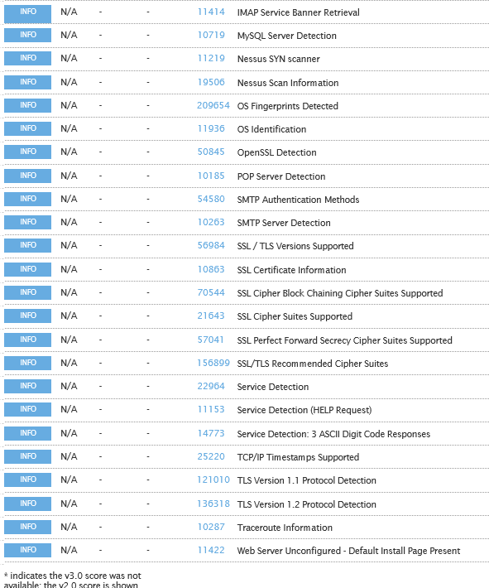

Brute Force
Randomised usernames with a word list containing more than 2.5 million words and common passwords were brute forced SSH’s onto the server using Hydra.

Hydra works by using different approaches to perform brute-force attacks in order to guess the right username and password combination. Hydra is commonly used by penetration testers together with a set of programmes like crunch, cupp etc, which are used to generate wordlists.

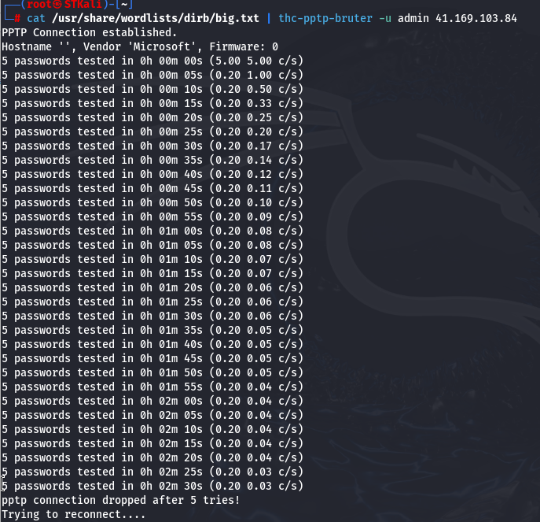

As per the HYDRA screen shot above, all know accounts have been scanned and with no passwords found. We are satisfied with the results.

NETWORK CONFIGURATION AND SECURITY pOLICIES

Internal Network Scan

The Internal Network Scan Report will be provided as a separate attachment.

Ambledown User List

Name | Type | Description
ABSA Gap Analysis - SCO'S Deny | Security Group - Global
Administrator | User | Built-in account for administering the computer/domain
Allowed RODC Password Replication Group | Security Group - Domain Local | Members in this group can have their passwords replicated to all read-only domain controllers in the domain
Ambledown Exco | Security Group - Global
Cert Publishers | Security Group - Domain Local | Members of this group are permitted to publish certificates to the directory
Denied RODC Password Replication Group | Security Group - Domain Local | Members in this group cannot have their passwords replicated to any read-only domain controllers in the domain
DHCP Administrators | Security Group - Domain Local | Members who have administrative access to DHCP service
DHCP Users | Security Group - Domain Local | Members who have view-only access to the DHCP service
DnsAdmins | Security Group - Domain Local | DNS Administrators Group
DnsUpdateProxy | Security Group - Global | DNS clients who are permitted to perform dynamic updates on behalf of some other clients (such as DHCP servers).
Domain Admins | Security Group - Global | Designated administrators of the domain
Domain Computers | Security Group - Global | All workstations and servers joined to the domain
Domain Controllers | Security Group - Global | All domain controllers in the domain
Domain Guests | Security Group - Global | All domain guests
Domain Users | Security Group - Global | All domain users
ensadmin | User
Enterprise Admins | Security Group - Universal | Designated administrators of the enterprise
Enterprise Read-only Domain Controllers | Security Group - Universal | Members of this group are Read-Only Domain Controllers in the enterprise
Gaurdrisk Ambledown | Security Group - Global
Gaurdrisk Broker | Security Group - Global
Gaurdrisk CaseMan | Security Group - Global
Gaurdrisk Claims | Security Group - Global
Gaurdrisk Compliance | Security Group - Global
Gaurdrisk Finance | Security Group - Global
Gaurdrisk Manco | Security Group - Global
Gaurdrisk Marketing | Security Group - Global
Group Policy Creator Owners | Security Group - Global | Members in this group can modify group policy for the domain
Guest | User | Built-in account for guest access to the computer/domain
IUSR_WIN-EUGSO7LO7PY | User | Built-in account for anonymous access to Internet Information Services
Manco users | Security Group - Global
Policies and Processors main | Security Group - Global
Policies and Processors users | Security Group - Global
RAS and IAS Servers | Security Group - Domain Local | Servers in this group can access remote access properties of users
Read-only Domain Controllers | Security Group - Global | Members of this group are Read-Only Domain Controllers in the domain
Schema Admins | Security Group - Universal | Designated administrators of the schema
SQLServer2005MSFTEUser$SBSSRV$MICROSOFT##SSEE | Security Group - Domain Local
SQLServer2005MSFTEUser$SBSSRV$SBSMONITORING | Security Group - Domain Local | Members in the group have the required access and privileges to be assigned as the log on account for the associated instance of SQL Server and SQL Server FullText Search in SQL Server 2005.
SQLServer2005MSSQLServerADHelperUser$SBSSRV | Security Group - Domain Local | Members in the group have the required access and privileges to be assigned as the log on account for the associated instance of SQL Server Active Directory Helper in SQL Server 2005.
SQLServer2005MSSQLServerADHelperUser$WIN-EUGSO7LO7PY | Security Group - Domain Local | Members in the group have the required access and privileges to be assigned as the log on account for the associated instance of SQL Server Active Directory Helper in SQL Server 2005.
SQLServer2005MSSQLUser$SBSSRV$MICROSOFT##SSEE | Security Group - Domain Local | Members in the group have the required access and privileges to be assigned as the log on account for the associated instance of Windows Internal Database.
SQLServer2005MSSQLUser$SBSSRV$SBSMONITORING | Security Group - Domain Local | Members in the group have the required access and privileges to be assigned as the log on account for the associated instance of SQL Server and SQL Server FullText Search in SQL Server 2005.
SQLServer2005SQLBrowserUser$SBSSRV | Security Group - Domain Local | Members in the group have the required access and privileges to be assigned as the log on account for the associated instance of SQL Server Browser in SQL Server 2005.
SQLServer2005SQLBrowserUser$WIN-EUGSO7LO7PY | Security Group - Domain Local | Members in the group have the required access and privileges to be assigned as the log on account for the associated instance of SQL Server Browser in SQL Server 2005.
Test | Distribution Group - Global
Unity SFTP Users | Security Group - Global
WSS_ADMIN_WPG | Security Group - Domain Local | Members of this group have write access to system resources used by Windows SharePoint Services.
WSS_RESTRICTED_WPG | Security Group - Domain Local | Group for the Windows SharePoint Services farm administrator. This group is required for the WSS Administration Service to function.
WSS_WPG | Security Group - Domain Local | Members of this group have read access to system resources used by Windows SharePoint Services.
WSUS Administrators | Security Group - Domain Local | WSUS Administrators can administer the Windows Server Update Services server.
WSUS Reporters | Security Group - Domain Local | WSUS Administrators who can only run reports on the Windows Server Update Services server.

Password Policies

- Complexity and known passwords we are comfortable with, we will however recommend extending the password length from 8 to 14 characters
- Windows Server 2008 is used and there is no more support or updates to this software, upgrade to newer version as a matter of urgency.
- Local firewall is disabled, enable and only allow services that is needed
- No Anti-Virus was detected or installed on the AD Server – Critical
- Consider changing the VPN from user/pass based authentication to user/cert-based authentication

Based on the previous reports dated April 2024, it was noticed that multiple recommendations were not implemented. We highly advise applying the relevant changes regarding the above.

Domain Policies

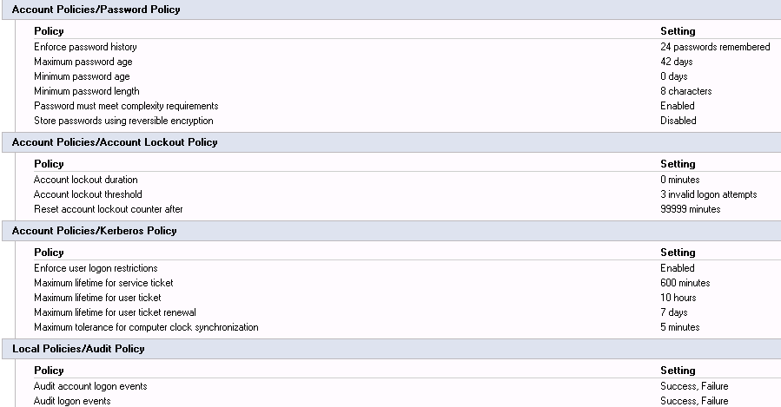

As per the above screenshot and with the information disclosed, we are satisfied with the results, however, we do recommend extending the minimum password length from 8 characters to 14 characters.

Domain Admin Users

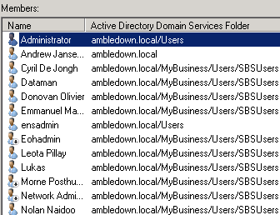

System Information

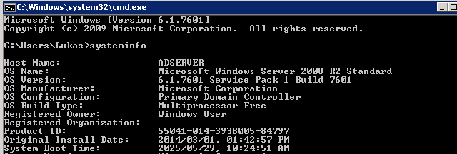

Server Windows Updates

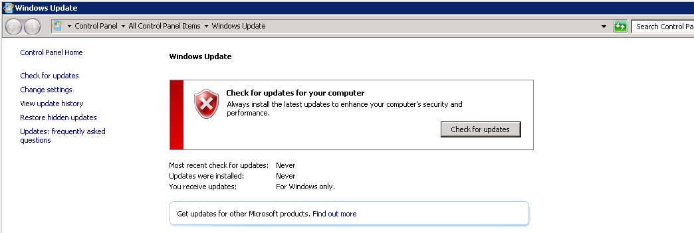

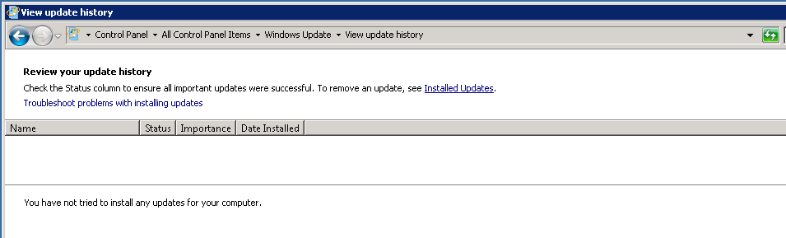

Server OS

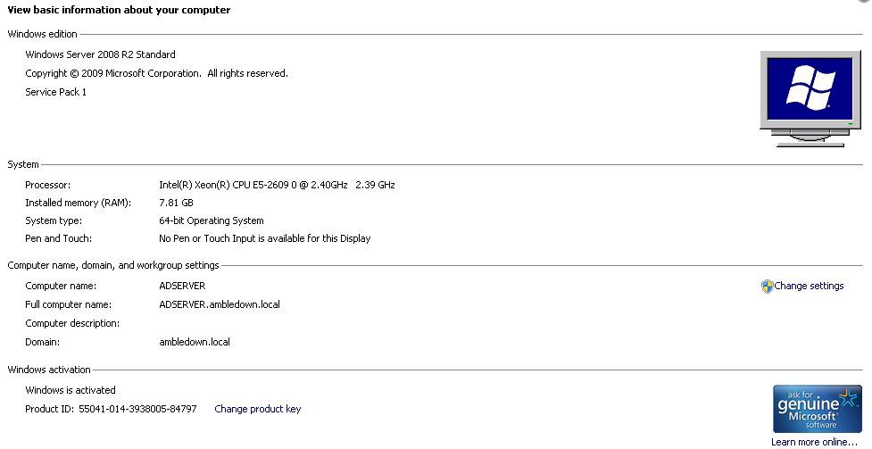

FortiGate Firewall

For Security reasons, we will not paste the firewall rules here, this can be obtained manually if need be.

We have only analysed the inbound rules as was the mandate and did not evaluate outbound, IPS or user policies. When we tried to login to the firewall, we were happy to note that entering the wrong password three times. We are also happy to know that the Web UI interface is not accessible via browser externally.

We cannot comment on rules created and why it’s needed or not, but we do note there might be some rules that is old/outdated/not needed anymore. Although they pose no direct risk, we would disable/delete what is not needed.

On the rest of the firewall configuration, we are comfortable.

Firewall Information

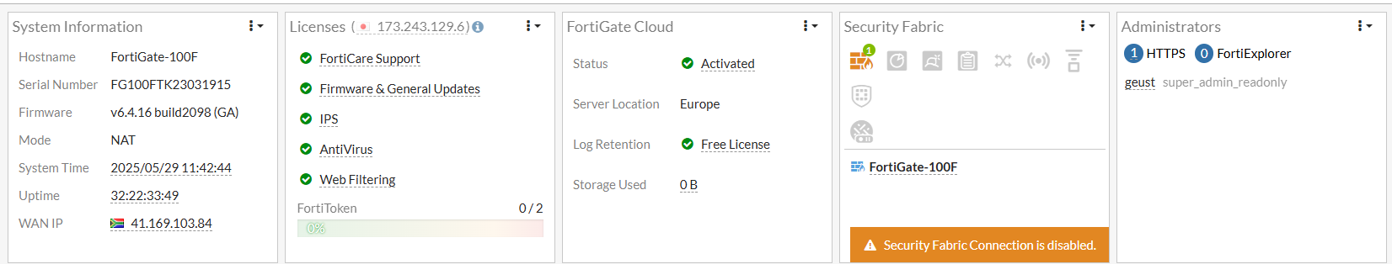

Wireless Network

We performed a wireless network scan/attack from Kali Linux.
The SSID should be hidden as its easy identifiable by name to which company it belongs and we could then detect easily what Encryption was used. Based on the encryption we knew the amount of characters that will be maximum and scanned the wireless network password.

Please consider changing the password to more Upper/lower/numeric/Symbolic Combinations.
Also, please consider when the SSID is hidden, to install a guest WIFI off the main network, separate Vlan with breakout.

- Available Wireless SSID’s:

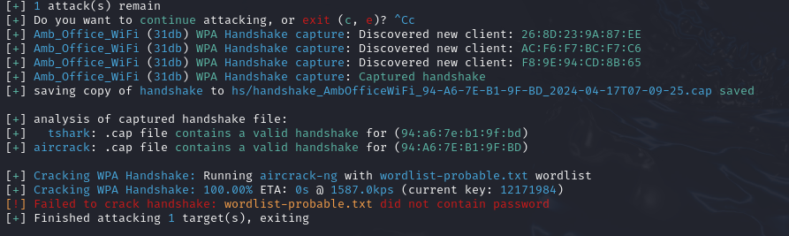

- Wireless Password Brute Force Attack:

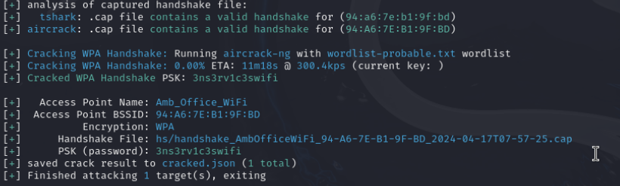

Based on the previous reports dated April 2024, it was noticed that the Wireless Key has still not been changed and the Wireless SSID has still not been hidden. We highly recommend applying the relevant changes regarding the above.

Reporting Conclusion

Based on the OWASP reports it is best to attach these separate to the reporting document. These reports can then be shared with the relevant contractors and/or support personnel to implement the changes and updates.

It is our view that from External Testing where the SSH port are not open to public, these vulnerabilities then become academic. However, we still recommend that the changes be implemented. Ambledown Financial Services is behind the managed FortiGate firewall.

The HTTPS updates as these are open to the public, low and medium risk, should be tested and implemented as soon as possible.

From a Hosted Infrastructure point of view, we are happy with the results. We do recommend that SenitnelOne is implemented into the production environment as soon as possible.
We also recommend where Operating systems are end of life or close to, they be upgraded.

As stated, based on the previous reports dated April 2024, multiple recommendations and changes were not implemented. We highly advise applying same as soon as possible.

Eleven (11) addendum reports are attached to this report and should be read as one document.

Two separate folders are included:

Folder 1: Public IP Scan – Main
Contains scan results performed directly from a public IP to target public IP addresses.
- Ambledown HO Firewall – GREENBONE
- Ambledown HO Firewall – NESSUS
- Ambledown HO Firewall – OWASP
- Ambledown Live Server – GREENBONE
- Ambledown Live Server – NESSUS
- Ambledown UAT Server – GREENBONE
- Ambledown UAT Server – NESSUS
- Ambledown UAT Server – OWASP

Folder 2: Internal IP Scan – Main
Contains scan results from allowed public IPs to internal production server IPs
- Ambledown Domain Controller – GREENBONE
- Ambledown Firewall Internal – GREENBONE
- Ambledown Internal Network Scan

With the following test performed:

- Network scanning
- Knows network attack (from Internet to the FW)
- External HTTP and Port exploits
- Vulnerability assessment on CVE
- Penetration testing on login ports i.e.: ssh open

Auditors

These audits were concluded over a period of seven (7) business days.
We hereby confirm that the above information is true and correct:

05th June 2025 – Krugersdorp, South Africa

_________________________ _________________________
Riaan van Jaarsveld Lukas Janse van Rensburg
Security Expert – CCSA / Certified Pen Tester Security Engineer

